MODEL QUESTION PAPER
Code No: CT4523- | SRGEC-R23
III B.Tech I Semester Regular Examinations
DATA WAREHOUSING AND DATA MINING
(Computer Science and Engineering, Artificial Intelligence and Data Science)
Time: 3 Hours Max. Marks: 70
Note: All questions from PART-A are to be answered in one place.
Answer all questions from PART-B. All Questions carry equal marks.

PART – A
10 × 2 = 20M
1. | List any two kinds of data that can be mined.
2. | Differentiate between Ordinal and Numeric attributes. Give Examples.
3. | What are the common problems that affect data quality?
4. | List any two methods of data normalization.
5. | List two attribute selection measures used in decision tree algorithms.
6. | State Bayes’ Theorem.
7. | Define support and confidence in association rule mining.
8. | Define maximal frequent itemset.
9. | List any two clustering techniques.
10. | What is the stopping condition in agglomerative clustering?

PART – B
5 × 10 = 50M
Unit - I
 |  | BL
2. | a) Compare Operational Database Systems and Data Warehouses with suitable examples. (5M)  b) Describe the Star, Snowflake, and Fact Constellation Schemas used in multidimensional modelling. (5M) | L3  L2
 | (OR)
3. | a) Explain the role of Data Mining in Business Intelligence applications. (5M)  b) Illustrate how histograms and scatter plots are used for data visualization. (5M) | L2  L3
Unit – II
4. | a) Illustrate the need for data preprocessing before applying mining algorithms. (5M)  b) Explain how histograms are used for data reduction with examples. (5M) | L3  L2
 | (OR)
5. | a) Explain data discretization by binning with an example. (5M)  b) Describe the data cleaning process and its role in improving data quality. (5M) | L2  L2
Unit – III
6. | a) Discuss how attribute selection measures such as information gain and gain ratio are used in decision tree construction. (5M)  b) Explain how IF–THEN rules are used for classification with examples. (5M) | L2  L2
 | (OR)
7. | Build the decision tree using ID3 algorithm for the concept Play-Golf using the database shown below. Also predict the class label of the unknown data X given below using the decision tree constructed. (10M)  X=(Outloook=Rainy, Temp=cool, Humidity=High, Wind=True)  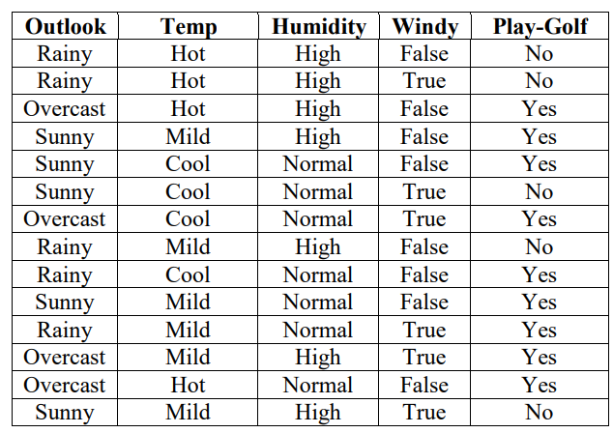 | L3
Unit - IV
8. | a) Illustrate with a suitable example how apriori algorithm finds frequent item sets from the transactional database. (5M)  b) A database has six transactions. Let min-sup = 50% and min-conf = 75%. Find all frequent item sets using Apriori algorithm. List all the strong association rules. (5M)  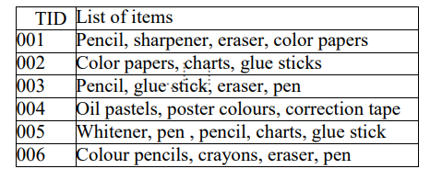 | L3  L4
 | (OR)
9. | Can we design a method that mines the complete set of frequent item sets without candidate generation? If yes, explain with the example table mentioned below. (10M) | L4
  Tid | List of Items
  001 | milk, dal, sugar, bread
  002 | Dal, sugar, wheat,jam
  003 | Milk, bread, curd, paneer
  004 | Wheat, paneer, dal, sugar
  005 | milk, panner, bread
  006 | Wheat, dal, paneer, bread
Unit - V
10. | a) What is cluster analysis? Briefly explain different types of clustering methods. (5M)  b) Write short notes on (i) DBSCAN (ii) Hierarchical clustering (iii) Agglomerative Clustering. (5M) | L2  L2
 | (OR)
11. | a) Write the algorithm of bisecting K-means and how it is different from simple K-means? (5M)  b) Compare clustering and classification with suitable examples. (5M) | L2  L3

